 | B.M.S. COLLEGE OF ENGINEERING, BANGALORE-19  Computer Science & Engineering
INTERNALS-1
Course Code: 23CS5PEAAM |  | Course Title: Advanced Algorithms
Semester: 5 |  | Maximum Marks: 40 | Date:- 5-11-2024
Faculty Handling the Course: |  | Dr. GRP, Dr. BSR, NM, PP
Instructions: Internal choice provided in Part C.

PART-A
Total 5 Marks (No Choice)
Q.No. | Question | Marks | CO-PO
1. | Outline any 3 characteristics of Dynamic programming. How is it different from a Greedy approach? | 5 | 1-1

PART-B
Total 15 Marks (No Choice)

Q.No. | Question | Marks | CO-PO
2 a) | Apply Ford Fulkerson algorithm to find the maximum flow that can flow from source S to sink t for the following flow network.  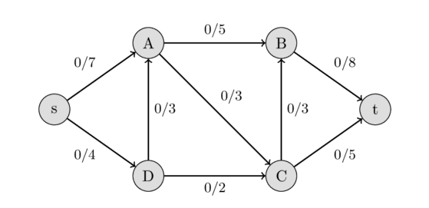 | 5 | 1-1
2 b) | Given the three operation: replace, insert and delete. Find the minimum number of operations required to convert following string 1 to string 2 using dynamic programming technique:  String 1: “elephant” String 2: “relevant”. | 5 | 2-2
2 c) | Analyze and mention whether the following two DNA’s belongs to same group or not. If sequence of size more than 4 is found, then they belong to the same group otherwise they not belong to the same group:  S1= “ABCBDAB “ S2= “BDCABA” | 5 | 2-2

PART- C
Total 20 Marks

Q.No. | Question | Marks | CO-PO
3 a) | Justify how Matrix-Chain multiplication using Dynamic Programming technique reduces number of multiplications required compare to Naïve method for the following data:  A1 of order 4X10  A2 of order 10X3  A3 of order 3X12  A4of order 12X20  Design an algorithm for the same and derive the time complexity of this algorithm. | 10 | 2-2
 | OR
3 b) | Suppose there is a building with 6 floors and you are given 3 glass pieces. Determine the minimum number of experiments required to find the threshold floor from which you can drop a glass piece without breaking. Write an algorithm for the same and find its time complexity. | 10 | 2-2
4a) | Find the minimum cost involved in reaching from node S to node T for the following multi stage graph using forward approach. Design an algorithm for the same  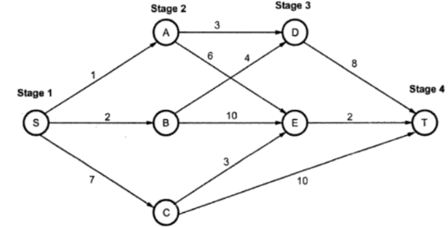 | 10 | 1-1
 | OR
4b) | Find longest increasing subsequence for the following sequence of integers: 0,4,12,2,10,6,9,13,3,11,7,15. Design an algorithm and find the time complexity of this algorithm. | 10 | 2-2

***ALL THE BEST***

